SECURITIES AND EXCHANGE COMMISSION
Washington, D.C. 20549
______________
FORM 8-K
______________

Current Report
Pursuant to Section 13 or 15(d) of the Securities Exchange Act of 1934
Date of Report (Date of earliest event reported): September 15, 2026

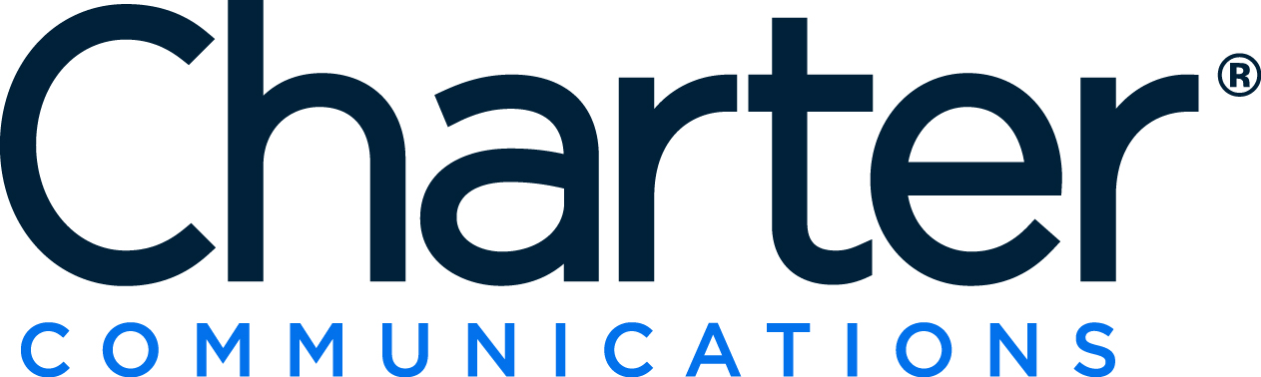

Charter Communications, Inc.
CCO Holdings, LLC
CCO Holdings Capital Corp.
(Exact name of registrant as specified in its charter)

Delaware
(State or other jurisdiction of incorporation or organization)
001-33664 |  |  |  |  |  | 84-1496755
001-37789 |  |  |  |  |  | 86-1067239
333-112593-01 |  |  |  |  |  | 20-0257904
(Commission File Number) |  |  |  |  |  | (I.R.S. Employer Identification Number)

400 Washington Blvd.
Stamford, Connecticut 06902
(Address of principal executive offices including zip code)

(203) 905-7801
(Registrant’s telephone number, including area code)

Not Applicable
(Former name or former address, if changed since last report)

Check the appropriate box below if the Form 8-K filing is intended to simultaneously satisfy the filing obligation of the registrant under any of the following provisions:

☐ Written communications pursuant Rule 425 under the Securities Act (17 CFR 230.425)
☐ Soliciting material pursuant to Rule 14a-12 under the Exchange Act (17 CFR 240.14a-12)
☐ Pre-commencement communications pursuant to Rule 14d-2(b) under the Exchange Act (17 CFR 240.14d-2(b))
☐ Pre-commencement communications pursuant to Rule 13e-4(c) under the Exchange Act (17 CFR 240.13e-4(c))

Securities registered pursuant to Section 12(b) of the Act:
Title of each class |  |  | Trading Symbol(s) |  |  | Name of each exchange on which registered
Class A Common Stock, $.001 Par Value |  |  | CHTR |  |  | NASDAQ Global Select Market
Series A Cumulative Redeemable Preferred Stock $.001 Par Value |  |  | CHTRP |  |  | NASDAQ Global Select Market

Indicate by check mark whether the registrant is an emerging growth company as defined in Rule 405 of the Securities Act of 1933 (§230.405 of this chapter) or Rule 12b-2 of the Securities Exchange Act of 1934 (§240.12b-2 of this chapter). Emerging growth company ☐

If an emerging growth company, indicate by check mark if the registrant has elected not to use the extended transition period for complying with any new or revised financial accounting standards provided pursuant to Section 13(a) of the Exchange Act. ☐

ITEM 7.01. REGULATION FD DISCLOSURE.

On September 15, 2026, Charter Communications, Inc. (the “Company”) issued a press release (the “press release”) announcing that its board of directors declared a quarterly cash dividend which will be payable on October 15, 2026 to stockholders of record of the Company’s Series A Cumulative Redeemable Preferred Stock at the close of business on September 30, 2026. The full text of the press release is attached hereto as Exhibit 99.1 and is incorporated by reference into this Item 7.01.

The disclosure in Item 7.01 of this Current Report on Form 8-K and the press release attached hereto as Exhibit 99.1 are being furnished to the Securities and Exchange Commission in satisfaction of the public disclosure requirements of Regulation FD and shall not be deemed "filed" for any purpose.

ITEM 9.01. FINANCIAL STATEMENTS AND EXHIBITS.

Exhibit |  |  |  |  |  | Description
99.1 |  |  |  |  |  | Press Release, dated September 15, 2026.
104 |  |  |  |  |  | The cover page from this Current Report on Form 8-K, formatted in Inline XBRL.

SIGNATURES

Pursuant to the requirements of the Securities Exchange Act of 1934, as amended, each of Charter Communications, Inc., CCO Holdings, LLC and CCO Holdings Capital Corp. has duly caused this Current Report to be signed on its behalf by the undersigned hereunto duly authorized.
 |  |  | CHARTER COMMUNICATIONS, INC.
 |  |  | Registrant
 |  |  | By: |  |  |  |  |  | /s/ Kevin D. Howard
 |  |  |  |  |  |  |  |  | Kevin D. Howard
Date: September 15, 2026 |  |  |  |  |  |  |  |  | Executive Vice President, Chief Accounting Officer and Controller
 |  |  | CCO Holdings, LLC
 |  |  | Registrant
 |  |  | By: |  |  |  |  |  | /s/ Kevin D. Howard
 |  |  |  |  |  |  |  |  | Kevin D. Howard
Date: September 15, 2026 |  |  |  |  |  |  |  |  | Executive Vice President, Chief Accounting Officer and Controller
 |  |  | CCO Holdings Capital Corp.
 |  |  | Registrant
 |  |  | By: |  |  |  |  |  | /s/ Kevin D. Howard
 |  |  |  |  |  |  |  |  | Kevin D. Howard
Date: September 15, 2026 |  |  |  |  |  |  |  |  | Executive Vice President, Chief Accounting Officer and Controller

Exhibit 99.1

Charter Declares Quarterly Cash Dividend on Series A Cumulative
Redeemable Preferred Stock

Stamford, CT – September 15, 2026 – Charter Communications, Inc. (NASDAQ: CHTR, CHTRP) (the “Company”) today announced that its Board of Directors declared the regular quarterly cash dividend payable to holders of its Series A Cumulative Redeemable Preferred Stock (the “Charter Preferred Stock”) (NASDAQ: CHTRP). The per share amount of the quarterly cash dividend will be $0.43750001, payable in cash on October 15, 2026 to holders of record of the Charter Preferred Stock at the close of business on September 30, 2026.

As previously disclosed, 7,183,812 shares of Charter Preferred Stock were issued in connection with the acquisition of Liberty Broadband Corporation (“Liberty Broadband”). At the effective time of the acquisition, each share of Liberty Broadband Series A Cumulative Redeemable Preferred Stock was converted into one newly issued share of Charter Preferred Stock. The Charter Preferred Stock is entitled to 1/3 of a vote per share, has a liquidation preference of $25 per share plus accrued but unpaid dividends, pays dividends quarterly at a 7% annual rate, and is mandatorily redeemable on March 9, 2039.

About Charter

Charter Communications, Inc. (NASDAQ: CHTR, CHTRP) is the leading broadband and video company in the nation and the fastest growing mobile provider in its footprint, with services available to more than 70 million homes and small to large businesses across 45 states through its Spectrum brand. Founded in 1993, Charter has evolved from providing cable TV to streaming, and from high-speed Internet to a converged broadband, WiFi and mobile experience. Over the Spectrum Fiber Broadband Network and supported by our 100% U.S.-based employees, the Company offers Seamless Connectivity and Entertainment with Spectrum Internet®, Mobile, TV and Voice products.

More information can be found at corporate.charter.com.

Contacts:
Media: |  |  | Analysts:
Justin Venech |  |  | Stefan Anninger
203-905-7818 |  |  | 203-905-7955

